**OOPs Concept:**

Data Hiding

Abstraction

Encapsulation

Tightly encapsulated Class

Is-A Relationship

Has-A Relationship

Method Signature

Overloading

Overriding

Static Control Flow

Instance Control Flow

Constructors

Coupling

Cohesion

Type-casting

**Data Hiding:** Outside person should not get hold of internal data. Internal data should not go out directly. This oops feature is nothing but Data hiding. After validation outside person can access our internal data. Main advantage of data hiding is security.

Ex1: After providing proper username and password, we can check the Gmail inbox information.

Even valid customer of bank can only access his account information. By declaring data member (Variable) as private we can achieve data hiding.

Ex: public class Account {

private double balance;

public double getBalance () {

return balance;

}

}

**Note*:** It is highly recommended to declare data member (variable) as private.

**Abstraction:**

Hiding internal implementation and just highlight the set of services what we are offering is the concept of abstraction.

Main advantages of abstraction are:

1. We can achieve security because we are not highlighting our internal implementation.
2. Without affecting outside person, we can able to perform any type of changes in our internal system. Hence, enhancement will become easy.
3. It improves maintainability of the application.
4. Improves easiness to use our system.
5. By using interfaces and abstract classes we can implement abstraction.

**Encapsulation**:

The process of binding data and corresponding methods into a single unit is called encapsulation.

Class students {

Data members + methods (behavior)

}

If any component follows data hiding and abstraction such type of component is said to be encapsulated component.

**Encapsulation = Data Hiding + Abstraction.**

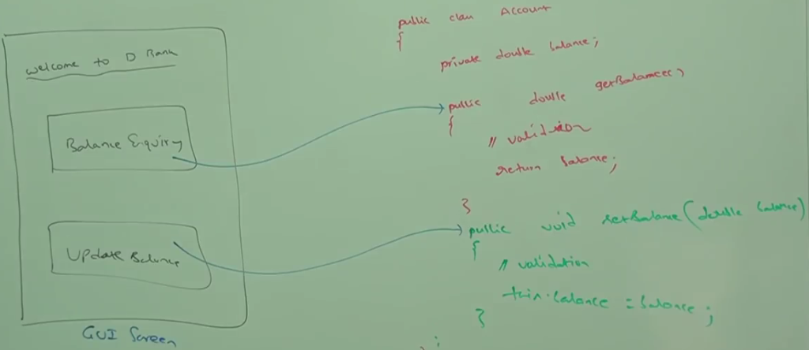

**Advantage**:

1. We can achieve security.
2. Enhancement will become easy.
3. Improves maintainability of the application.

**Disadvantage**:

Increases length of the code and slows down execution.

**Tightly encapsulated class:**

A class is tightly encapsulated if each variable declared as private. Whether class contains corresponding getter or setter methods or not. Whether these methods are public or not, we are not required to check.

If the parent class is not tightly encapsulated then no child class is tightly encapsulated.

**IS-A relationship**

1. Inheritance –Also known as Inheritance
2. Extends—By using extends keyword we can implement IS-A relationship.
3. Reusability—Main advantage of IS-A relationship is code reusability.

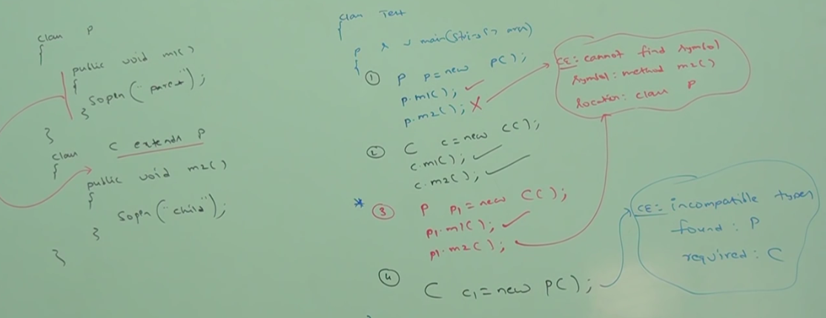

1. Whatever methods parent has by default available to the child and hence on the child reference, we can call both parent and child class methods.
2. Whatever methods child has by default not available to the parent. Hence, on the parent reference we can’t call child specific methods.
3. Parent reference can be used to hold child object. But using that reference we can’t call child specific methods. But we can call methods present in parent class.
4. Parent reference can be used to hold child object. But child reference can’t be used to hold parent object.

**Has-A** relationship is also known as composition or aggregation. No specific keyword to implement

has-A. Most of the time we are depending on new keyword.

Advantage of Has-A relationship is Reusability of code.

Ex: 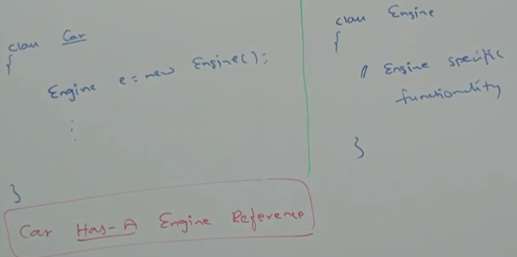

**Difference between composition and aggregation**

Without existing container object if there is no chance of existing contained object and container and contained objects are strongly associated. This strong association is nothing but composition.

Ex: University consists of several dept. Without existing University there is no chance of existing dept.

Hence University and department are strongly associated and this strong association is nothing but Composition.

**Aggregation**: Without existing container object if there is chance of existing contained object then container and contained objects are weakly associated. This weak association is nothing but aggregation.

Ex: Department consists of several professors. Without existing department there may be a chance of existing professor object. Hence, Department and Professor objects are weakly associated. This weak association is nothing but Aggregation.

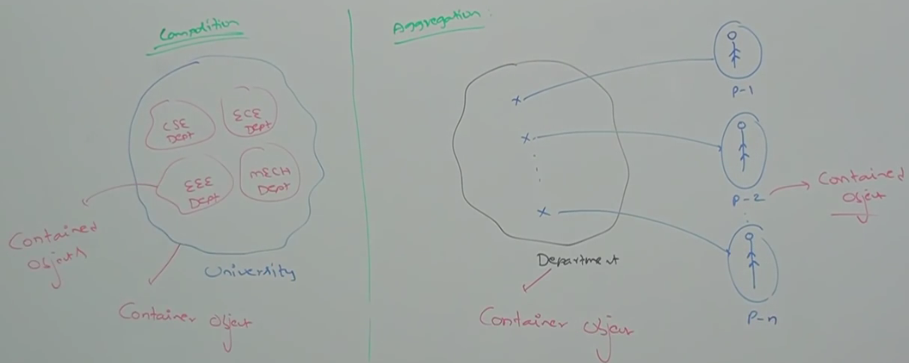

**Note**\*: In composition objects are strongly associated. Whereas, in aggregation objects are weakly associated.

**Composition**: Container Object holds directly contained objects.

**Aggregation**: Container Object holds just references of contained objects.

**IS-A vs Has-A**

------------------

If total functionality of a class is required then we should go for IS-A.

Ex: class Person {}, class Student {}

If part of functionality is required then we should go for Has-A relationship.

Ex: class Test {}, class Demo {Test t = new Test ();}

**Overloading:**

2 methods are overloaded if both methods have same name and different argument types.

In C, method overloading concept is not available. Hence, we can’t declare multiple methods with same name but different argument types. If there is a change in argument type, compulsory we should go for new method name (which increases complexity of programming).

Ex: abs (int i) ,labs (long i), fabs(double i),

In Java we can declare multiple methods with same name with different argument types. Such type of methods is called overloaded methods.

Ex: abs (int i);

abs (long i);

abs (double d);

In overloading method resolution is always taken care by **compiler based on reference type**. Hence, overloading is also considered as compile time polymorphism or static polymorphism or early binding.

**Case1:** Automatic promotion in overloading:

While resolving overloaded method if exact match method is not available then we won’t get any compile time error immediately. First it will promote argument to the next level and check whether matched method is available or not. If matched method is available then it will be considered. If the matched method is not available then compiler promotes argument once again to the next level. This process will be continued until all possible promotions still if the matched method is not available then we will get compile time error. Following are all possible promotions in overloading.

Byte->Short->int->long->float->double

Char->int->float->double

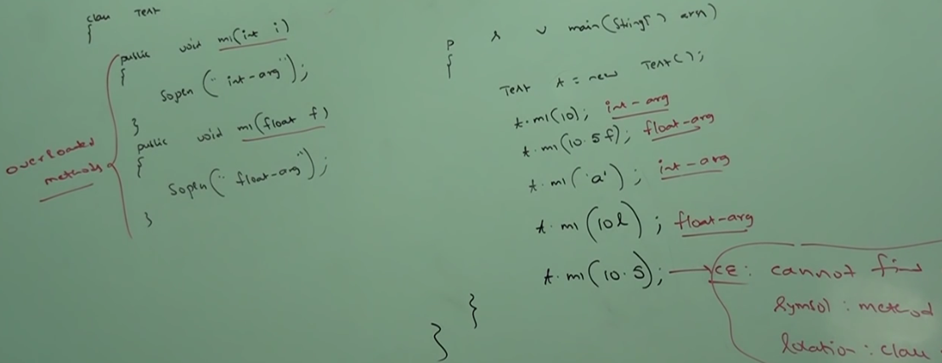

**Case2**: String and Object version

While resolving overloaded methods compiler gives precedence for child type argument when compared with parent type argument

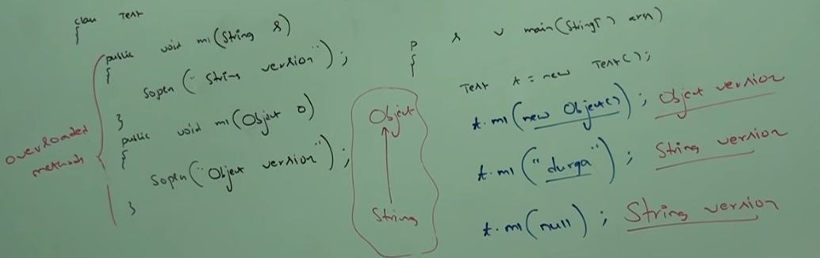

**Case3**: String and StringBuffer

As both String and StringBuffer are in the same level, compile time error will come saying ambiguous method.

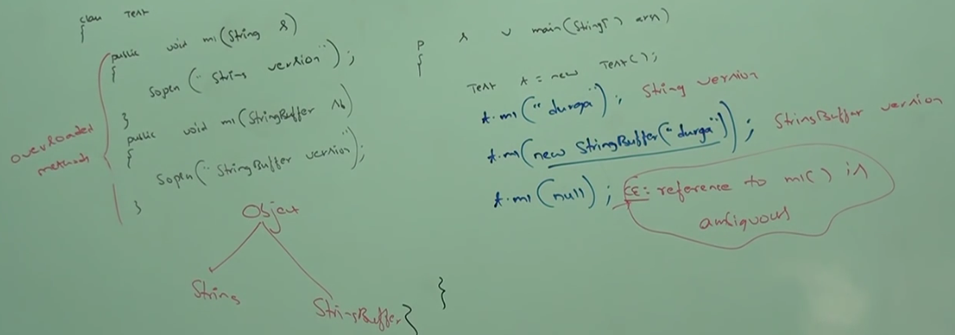

**Case4**: Int and Float

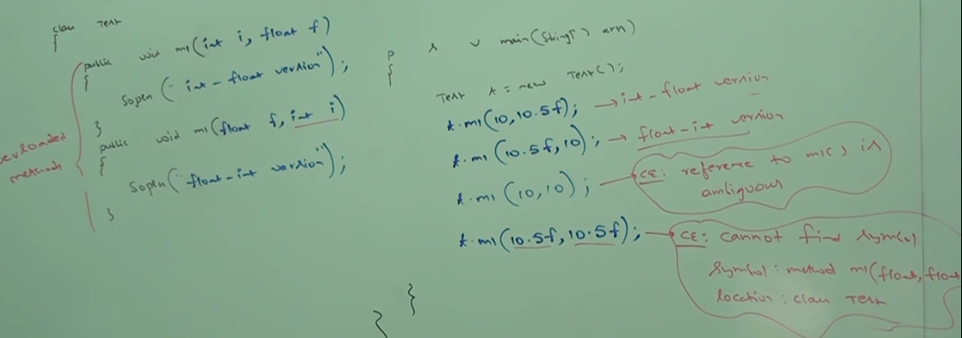

**Case5**: int and var arg methd

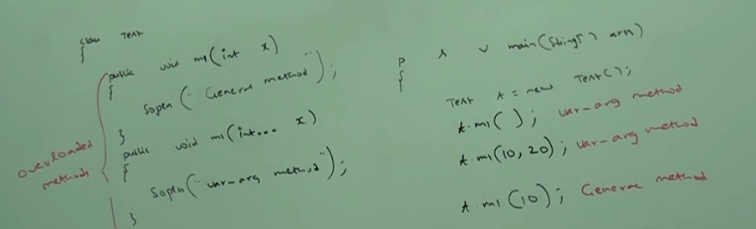

**Note*:** In general Var arg method will get least priority. If no other method matches this one will be executed. It is like default method inside switch.

**Case6:** In overloading method resolution is taken care by compiler based on reference type. In overloading run-time object won’t play any role.

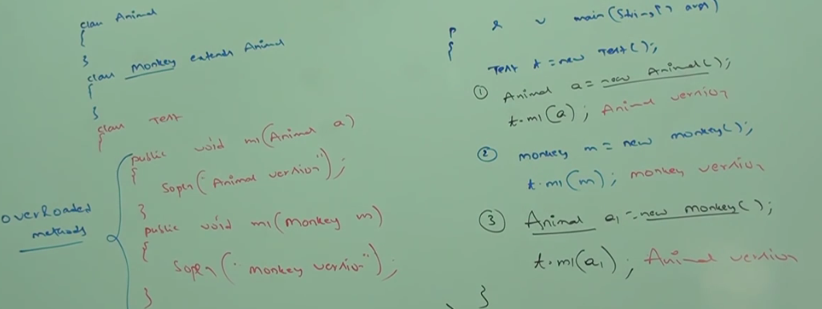

**Overriding**:

In overriding method resolution is always taken care by JVM based on runtime object. Hence, overriding is also considered as runtime polymorphism or dynamic polymorphism or late binding.

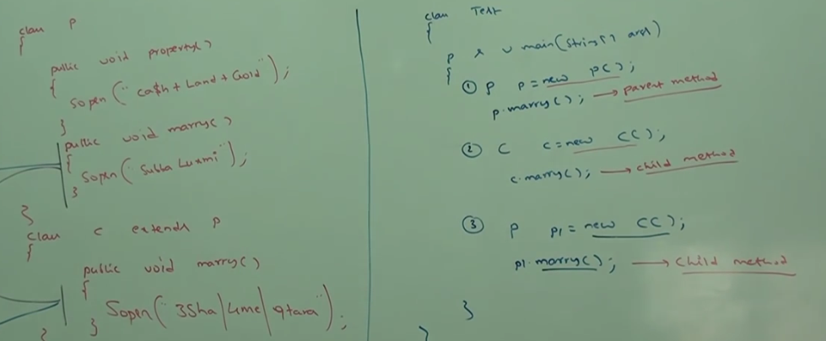

**Rules:**

1. Method name and argument types must match. I.e. Method signature must be same.
2. In overriding return type must be same. **This rule is applicable until 1.4 version only. From 1.5 version onwards, we can take co-variant return types**. According to this child class method return type need not be same as parent method return types. It’s child type also allowed.

Ex:

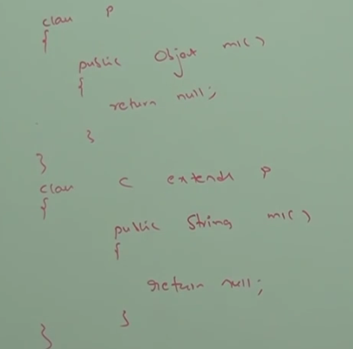

1. Co-variant written type concept applicable only for object types. But not for primitive types.

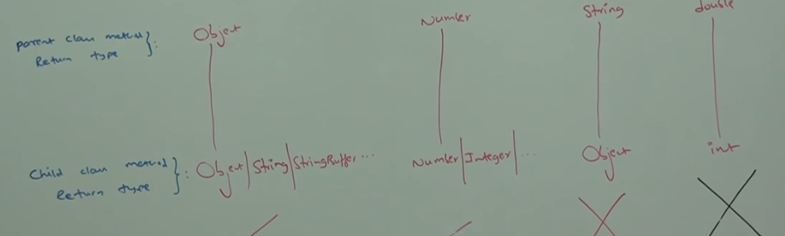

1. Parent class private methods not available to the child. Hence, overriding concept not applicable for private methods. Based on the requirement we can define exactly same method in child class. It is valid but not overriding.

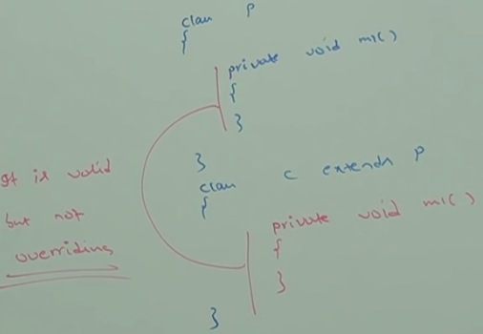

1. We can’t override parent class final method in child classes. If we are trying to override we will get compile time error.

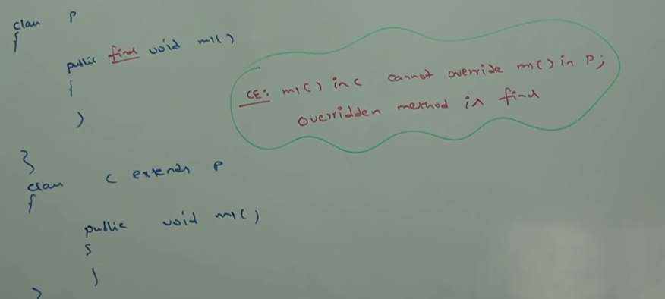

1. Parent class abstract method we should override in child class to provide implementation.

abstract class p {

public abstract void m1 ();

}

Class c extends p {

Public void m1() {

……

}}

1. We can override non- abstract method as abstract. Main advantage of this approach is : we can stop the availability of parent method implementation to the next level child classes.

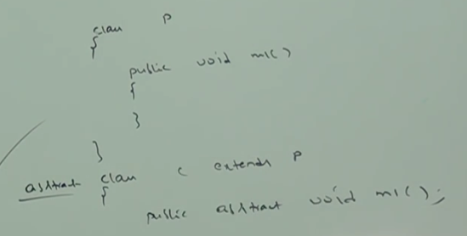

1. In overriding the following modifiers won’t keep any restriction.

Synchronized

Native

Strictfp

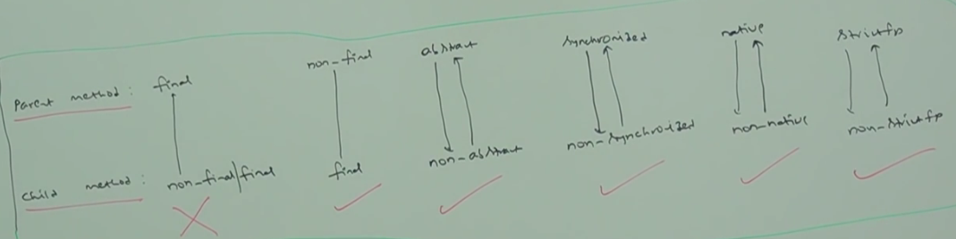

1. While overriding we can’t reduce scope of access modifiers. We can increase the scope.

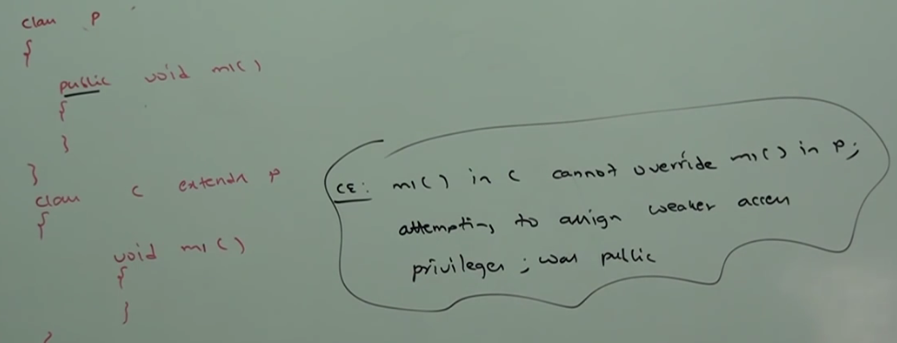

1. Rules for overriding:

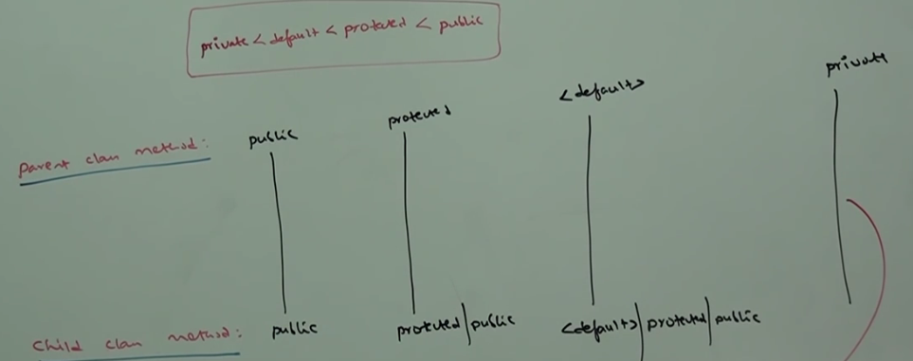

1. If child class method throws any checked exception then parent class method should throw the same checked exception or its parent. Otherwise, we will get compile time error.

No restriction for unchecked exception.

Example:

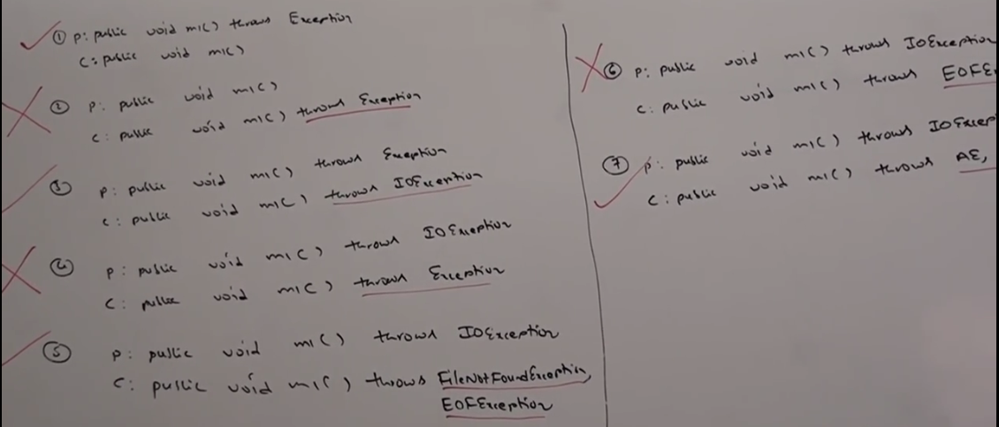

1. **Overriding with respect to static method**
2. We can’t override a static method as non-static. Otherwise, we will get compile time error.

method Name in child class cannot override method name in parent; overridden method is static.

1. We can’t override a non-static method as static. Otherwise, compile time error:

method Name in child class cannot override method name in parent; overriding method is static.

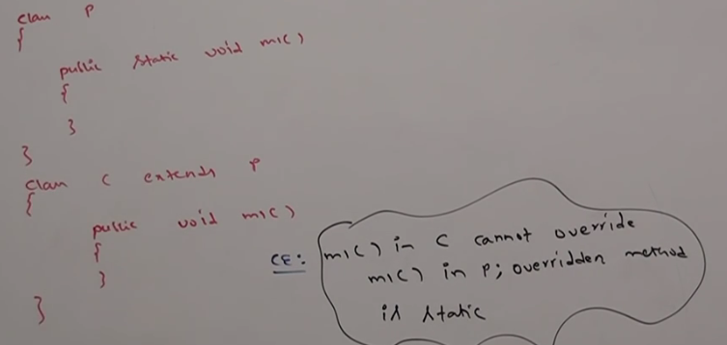

1. If both parent and child class methods are static then we won’t get any compile time error. It seems overriding concept is available for static methods. But it is not overriding and it is method hiding.

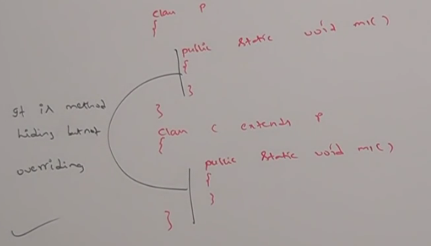

**Method Hiding and Overriding**

All rules of method hiding are exactly same as overriding except:

|  |  |
| --- | --- |
| Method Hiding | Overriding |
| Both static | Non-static |
| Compiler is responsible for method resolution based on compiler reference | JVM is responsible for method resolution based on Runtime object |
| Compile time polymorphism,  Static polymorphism,  Early binding | Runtime polymorphism,  Dynamic polymorphism,  Late binding |

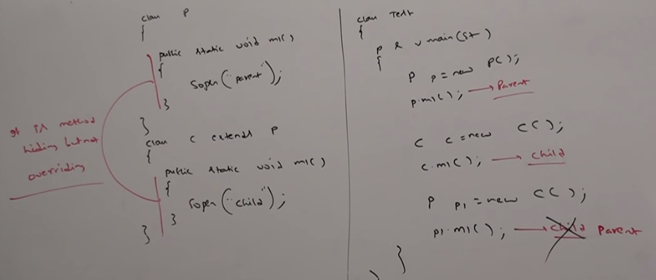

**Overriding with respect to var-args method:**

We can override var-arg method with another var-arg method only. If we are trying to override with normal method then it will become overloading but not overriding.

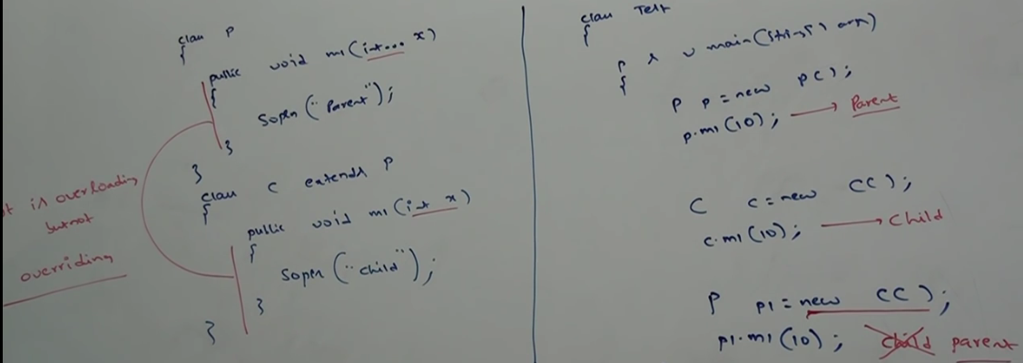

If child method is replaced by var-arg method then it will become overriding.

**Overriding with respect to variables**

Variable resolution always taken care by compiler based on reference type irrespective of whether the variable is static or non- static.

**Overriding concept applicable only for methods but not for variables.**

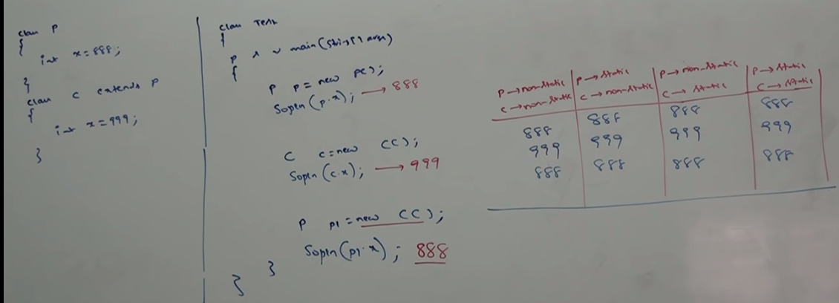

**Difference between overloading and overriding**

|  |  |  |
| --- | --- | --- |
| **Property** | **Overloading** | **Overriding** |
| Method Name | Must be same | Must be same |
| Argument type | Must be different (At least ordering) | Must be same (Including order) |
| Method Signature | Must be different | Must be same |
| Return Types | No restrictions | Must be same till 1.4  From 1.5 onwards co-variant return type allowed. |
| Private, static, final methods | Can be overloaded | Cannot be overridden |
| Access modifiers | No restrictions | The scope of access modifiers cannot be reduced but we can increase |
| Throws clause | No restrictions | If child method throws only checked exception then parent class method should throw the same checked exception or its parent exception.   * No restrictions for unchecked exceptions |
| Method resolution | Always taken care by compiler based on reference type | Always taken care by JVM based on runtime object |
| Also known as | Compile time polymorphism/static polymorphism/early binding | Run time polymorphism/Dynamic polymorphism/Late binding |

**In overloading we should check only method names (must be same) and argument types (must be different). We are not required to check remaining like return types, access modifiers etc.**

**In overriding everything we must check like method names, argument types, return types, access modifiers, throws class etc.**

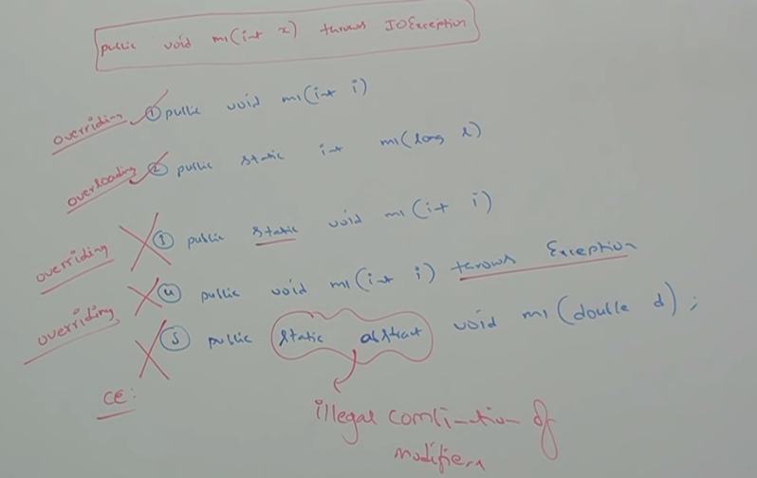

**Polymorphism**

One name but multiple forms is the concept of polymorphism.

Ex1: Method name is same. But we can apply different types of argument.

Parent and child are having different implementation methods.

Usage of parent reference to hold child object is the concept of polymorphism.

Ex: List l = new ArrayList ();

List l= new LinkedList();

List l = new stack ();

List l = new Vector ();

Parent class reference can be used to hold child object. But by using that reference we can call only the methods available in parent class. We can’t call child specific methods.

By using child reference, we can call both parent and child class methods.

Child c = new Child ();

c.m1();

c.m2();

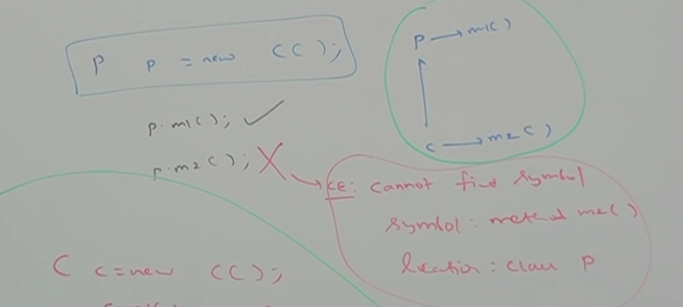

**When we should go for parent reference to hold child object**

If we don’t know exact runtime type of object then we should go for parent reference.

Ex: 1st element present in the ArrayList can be any type. Hence, return type of get method is object which can hold any object.

Ex: Object o = l.get(0); l is the arraylist

|  |  |
| --- | --- |
| **Child c = new Child ();** | **Parent p = new Child ();** |
| We can use this approach if we know exact runtime type of object | We can use this approach if we don’t know exact runtime type of object. |
| By using child reference, we can call both parent class and child class methods. This is the advantage of this approach. | By using parent reference, we can call only methods available in parent class. We can’t call child specific methods. This is the disadvantage of this approach. |
| We can use child reference to hold only particular child class object. Disadvantage of this approach | We can use parent reference to hold any child class object. Advantage of this approach. |

**Important concept of Oops:**

1. **Encapsulation --🡪**Security
2. **Polymorphism🡪**Flexibility
3. **Inheritance 🡪**Reusability

**Polymorphism**

1. **Static/compile-time/Early binding**
2. **Overloading**
3. **Method Hiding**
4. **Dynamic/run-time/Late binding**

**Coupling:**

The degree of dependency between the component is called coupling.

More dependency🡪Tightly coupled

Less dependency🡪Loosely coupled

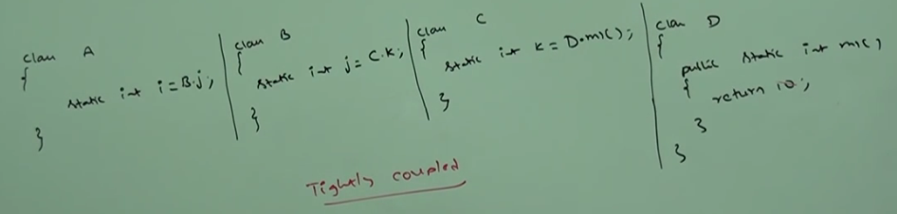

Tightly coupling is not a good programming practice as it has several disadvantages:

1. Without affecting remaining components, we can’t modify any component.
2. Enhancement is difficult.
3. It suppresses reusability.
4. Reduces maintainability of application.

Loosely coupling is a good programming practice.

**Cohesion:**

For every component a clear, well defined functionality is defined then that component is said to be followed high cohesion. High cohesion is always a good programming practice. It has several advantages.

1. Without affecting remaining components. we can any modify any component. Hence, enhancement will become easy.
2. Promotes reusability of the code (wherever validation is required, we can reuse the same vaildateServlet without rewriting).
3. Improves maintainability of application.

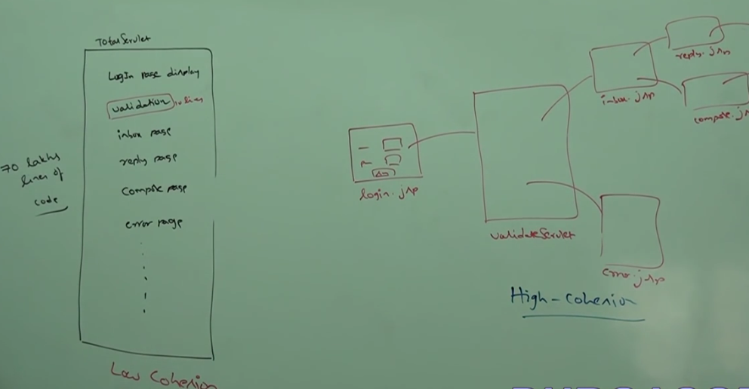

**Loosely coupling and High Cohesion are good programming practices.**

**Object Type casting:**

Parent reference can be used to hold child reference.

**Ex:** Object o = new String(“hello”);

We can use interface to hold implemented class.

**Ex:** Runnable r = new Thread ();

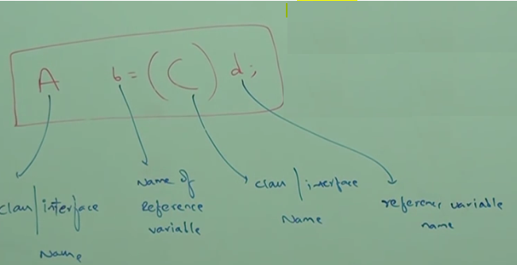

**Step1: Compile time checking 1.** Type of ‘d’ and ‘C’ must have some relationship (parent->child or child->parent or same type). If not compile time error will be shown as follows: Inconvertible types found: d type required: C

Ex1: Object o = new String (“hello”);

StringBuffer sb = (StringBuffer) o;-🡪Valid

Ex2: String s = new String (“hello”);

StringBuffer sb = (StringBuffer) s;-🡪CE: Inconvertible types found: java.lang.String required:

java.lang.StringBuffer

**Step2**: **Compile time checking 2.**

‘C’ must be either same or derived (child class) type of ‘A’. Otherwise, we will get compile time error saying: Incompatible type found ‘C’ required ‘A’.

Ex1: Object o = new String (“hello”);

StringBuffer sb = (StringBuffer) o; -🡪Valid

Ex2: Object o = new String (“aa”);

StringBuffer s = (String) o; -🡪CE: Incompatible types found: java.lang.String required:

java.lang.StringBuffer

**Step3**: Runtime checking

Runtime object type of ‘d’ must be either same or derived type of ‘C’. Otherwise, we will get runtime exception saying: Class Cast Exception.

Ex: Object o = new String (“hello”);

StringBuffer sb = (StringBuffer) o; -🡪Runtime saying

ClassCastException : j.l.String cannot be cast to j.l.StringBuffer

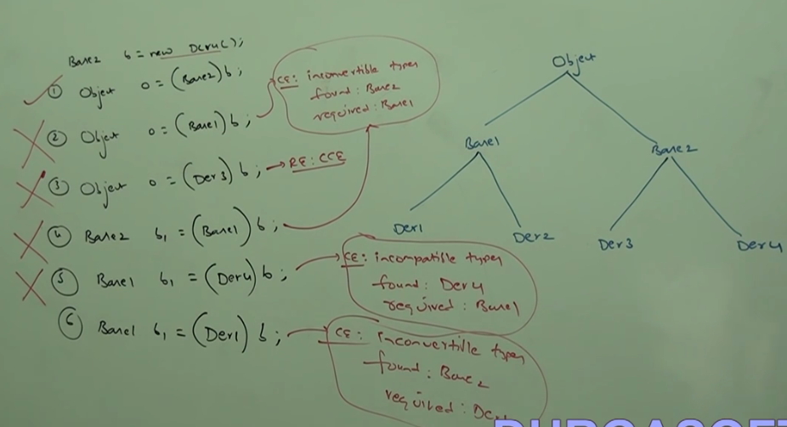

Through type casting we are not creating any new object. For the existing object we are providing another type of reference variable i.e. we are performing type casting but object casting.

Ex1:

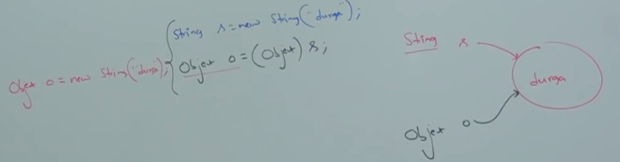

Ex2:

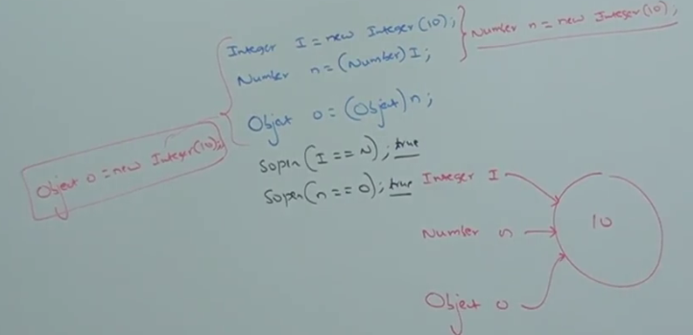

Parent reference can be used to hold child object. But by using that reference we can’t call child specific methods. We can call only methods available in parent class.

Ex3:

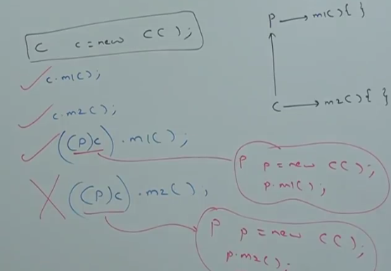

The below example is overriding and method resolution is at runtime object.

Ex4:

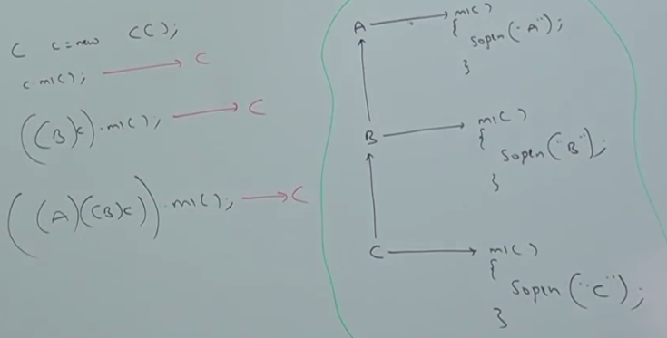

Ex5: Method hiding concept. Method resolution is always based on reference type.

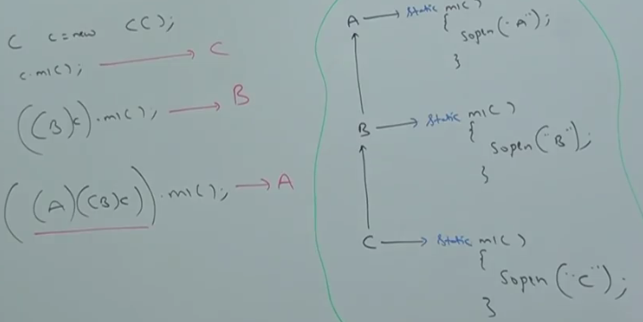

Ex6: Variable resolution is always based on reference type but not based on runtime object.

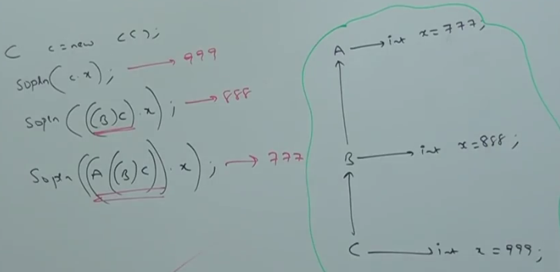

**Static Control Flow:**

Whenever we are executing a java class the following sequence of steps will be executed as part of static control flow:

1. Identification of static members from top to bottom;
2. Execution of static variable assignments and static blocks from top to bottom.
3. Execution of main method.

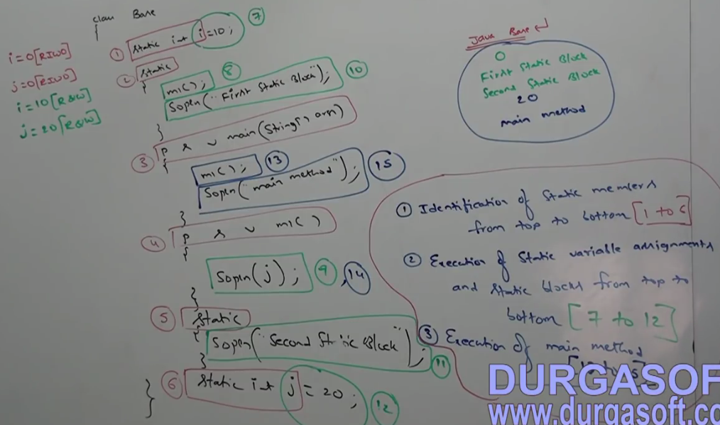

**Read Indirectly Write Only (RIWO):**

Inside static block if we are trying to read a variable, that read operation is called: **Direct read.**

If we are calling a method and within that method if we are trying to read a variable that read operation is called: **Indirect Read**.

If a variable is just identified by JVM and original value is not yet assigned then the variable is said to be in Read Indirectly Write Only state.

If a variable is in RIWO state then we can’t perform direct read. But we can perform indirect read. If we are trying to read directly then we will get compile time error saying: Illegal Forward Reference.

Ex:

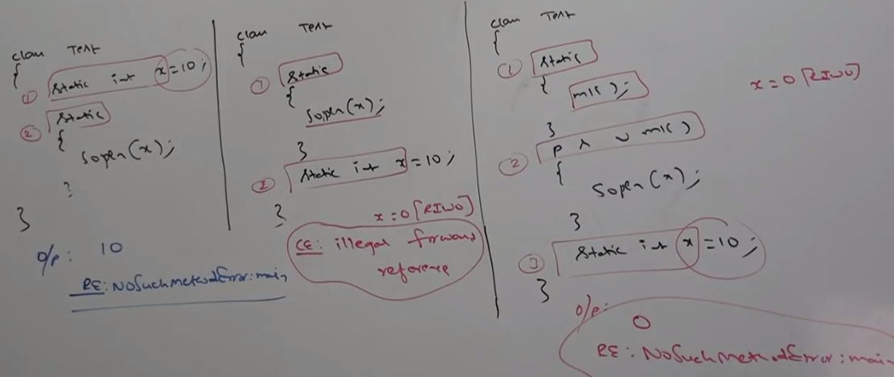

**Static Block:**

Static block will be executed at the time of class loading. Hence, at the time of class loading if we want to perform any activity we should define that inside static block.

At the time of java class loading the corresponding native libraries should be loaded. Hence, we have to define this activity inside static block.

Class Test {

static {

System.loadLibrary(“native library path”);

}

}

After loading every database driver class, we must register driver class with driver manager. But inside database driver class there is a static block to perform this activity. We are not responsible to register explicitly.

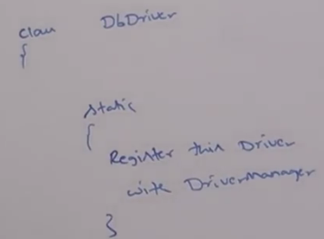

A class can have any number of static blocks. All these static blocks will be executed from top to bottom.

Q1. Without writing main method is it possible to print some statements to console.

Ans: Using static block;

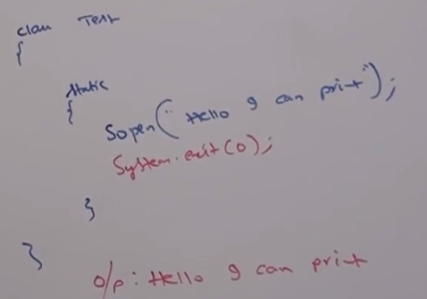

Q2. Without wring main and static block, is it possible to print some statement to console.

Ans: Yes

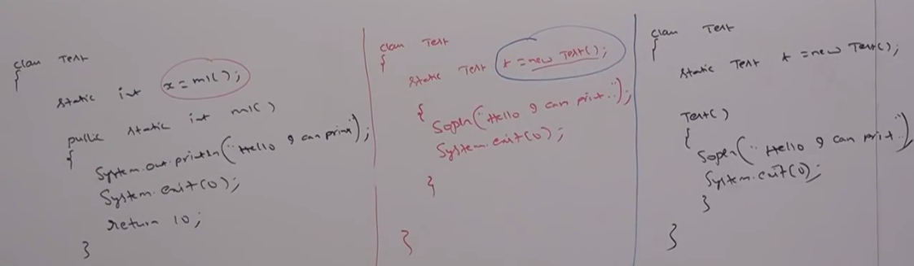

**FROM 1.7 version onwards, Main method is mandatory to start a program execution. Hence, 1.7 onwards, without main method it is impossible to print some statements to console.**

**Static control flow in parent to child relationship:**

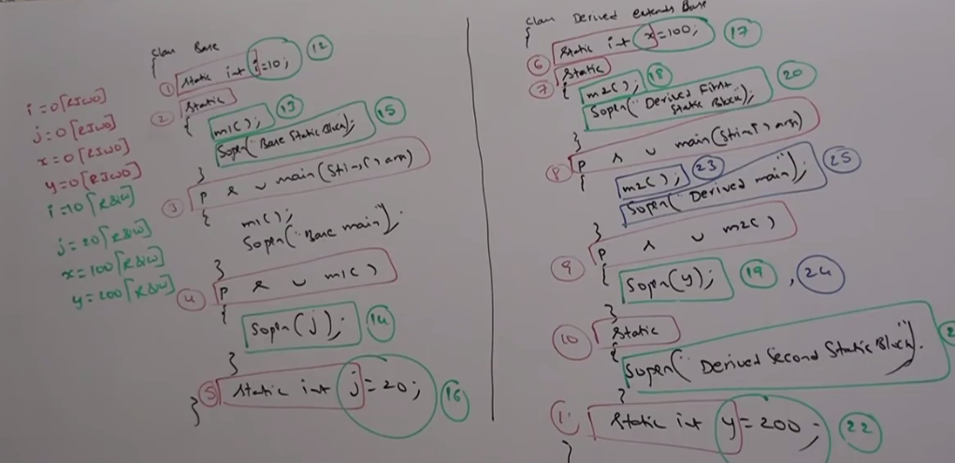

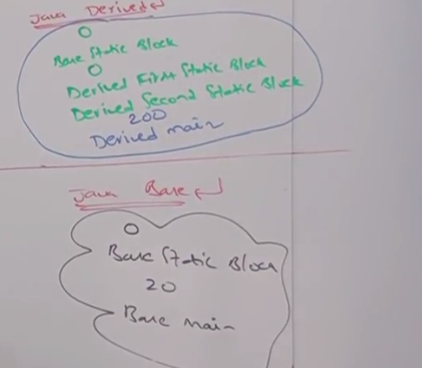

**Whenever we are loading child class then automatically parent class will be loaded. If Parent class loaded then child won’t be loaded.**

**Instance Control Flow:**

Whenever we are executing a java class first static control flow will be executed. In the static control flow if **we are creating an object the following sequence of events will be executed as part of instance control flow.**

1. Identification of instance members from top to bottom.
2. Execution of instance variable assignments and instance blocks from top to bottom.
3. Execution of constructor.

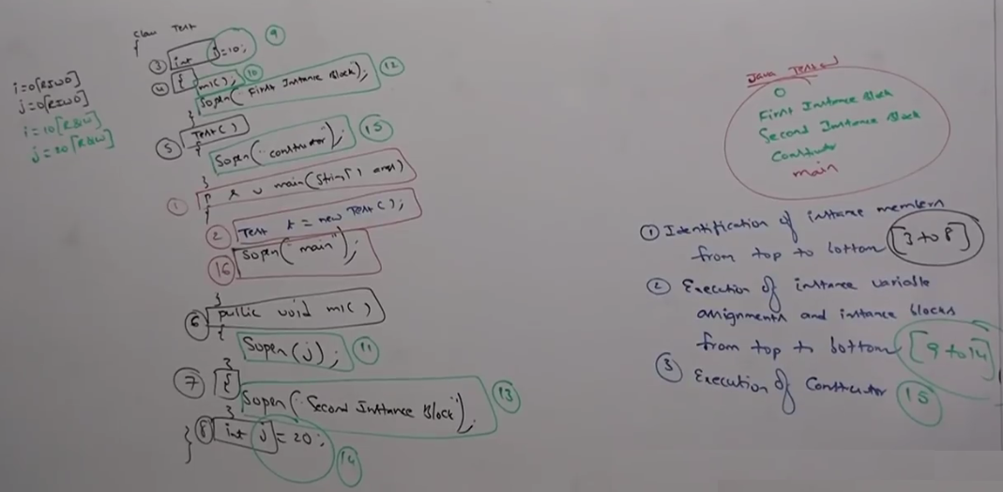

If #2 is commented then the output is: main

Static control flow is one-time activity which will be performed at the time of class loading. But instance control flow is not one-time activity and it will be performed for every object creation.

Object creation is the costliest operation. If there is no requirement then it is not recommended to create object.

**Instance control flow in parent to child relationship:**

Whenever we are creating child class object the following sequence of events will be performed automatically.

1. Identification of instance members from Parent to Child. **[4-14]**
2. Execution of instance variable assignments and instance blocks only in parent class. **[15-19]**
3. Execution of parent constructors. **[20]**
4. Execution of instance variable assignments and instance blocks only in child class. **[21-26]**
5. Execution of child constructors. **[27]**

**Output**: java child🡺

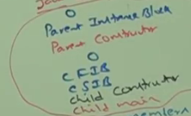

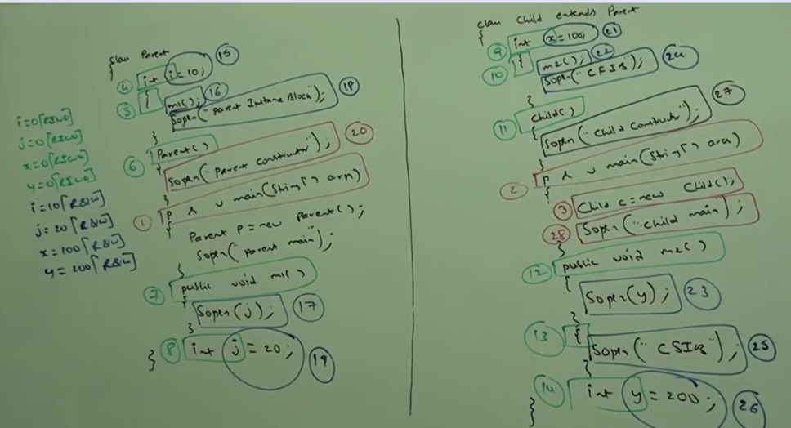

**Static and Instance Control Flow:**

**Ex1:**

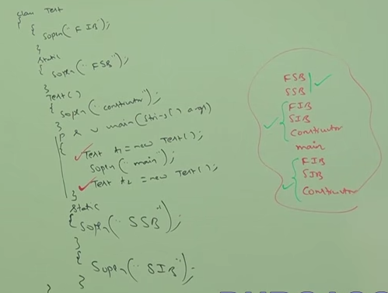

Ex2:

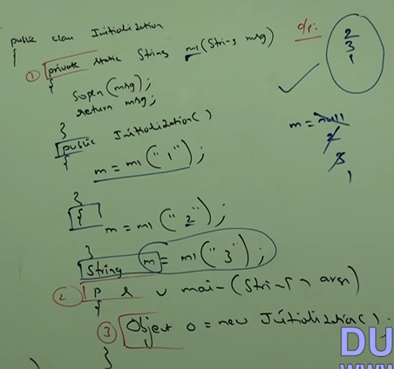

Ex3:

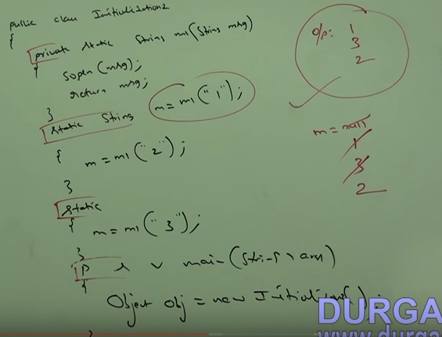

**Number of ways to create the object:**

1. **By Using new operator**

Test 1 = new Test ();

1. **By using new Instance method:**

Test t =(Test) Class.forName(“Test”).new Instance();

1. **By using factory method:**

Runtime r =Runtime.getRunTime();

DateFormat df= DateFormat.getInstance();

1. **By using clone () method:**

Test t1 = new Test ();

Test t2 = (Test) t1.clone ();

1. **By Using Deserialization**

FileInputStream fis = new FileInputStream (“abc.ser”);

ObjectInputStream ois = new ObjectInputStream(fis);

Dog d = (Dog) ois.readObject();

Main purpose of constructor is to perform initialize of an object but not to create object.

**Difference between Constructor and instance block**

Main purpose of constructor is to perform initialization of an object. Other than initialization if we want to perform any activity for every object creation then, we should go for instance block.

Ex: Updating one entry in the database for every object creation or incrementing count value for every object creation etc.

Both constructor and instance block have their own different purposes. Replacing one concept with another concept may not work always. Both constructor and instance block will be executed for every object. Instance block first followed by constructor.

**Demo program to print number of object created**

Class test {

static int count=0;

{count++;}

Test () {}

Test (int i) {}

Test (double d) {}

public static void main (String [] args){

Test t1 = new Test ();

Test t2 = new Test (10);

Test t3 = new Test (10.5);

System.out.print ("Total no of Objects created:"+count);

}

**Rule:**

1. Name of class and constructor must be same.

2. No concept of return type even void also.

3. Modifiers in constructor: public, private, protected, default

**Default Constructor:**

1. Compiler is responsible to generate the default constructor if the class does not contain any constructor.

2. Compiler is responsible to generate default constructor (but not JVM).

3. If we are not writing any constructor, then only compiler will generate default constructor.

4. If we are writing at least one constructor then compiler won't generate default constructor.

Hence, every class in java can contain constructor. It may be default constructor generated by compiler or customized constructor explicitly provided by programmer. But not both simultaneously.

**Prototype of default constructor:**

1. It is always no argument constructor.

2. The access modifier of default constructor is exactly same as access modifier of class.

This rule is applicable only for public and default.

3. It contains only one line.

Super (); -->No argument call to super class constructor.

**Programmer code vs Compiler generated code:**

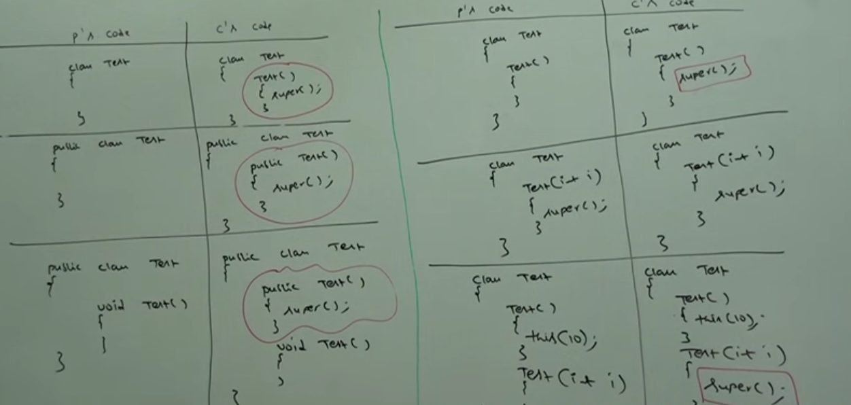

He first line inside every constructor should be either super () or this (). If we are not writing anything then compiler will always place super ();

**Case1:**

We can take or super () or this () only in first line of constructor. If we are trying to take anywhere else we will get compile time error.

**Case2:**

Within the constructor we can take either super () or this () but not both simultaneously.

**Case3:**

Call to super () must be first statement in constructor. We can use super () or this () only inside constructor. If we are trying to use outside of constructor we will get compile time error.

**Case4**:

We can call a constructor directly from another constructor only.

**super (), this ():**

1.These are constructor calls to call super class and current class constructors.

2. We can use only in constructors as first line.

3. we can use only once in constructor.

**super, this:**

1. These are keywords to refer super class and current class instance members.

2. We can use anywhere except static areas.

3. we can use any number of times.

Within a class we can declare multiple constructors. All these constructors having same name but different type of arguments. Hence, all these constructs are considered as over loaded constructors.

Overloading concept applicable for constructors.

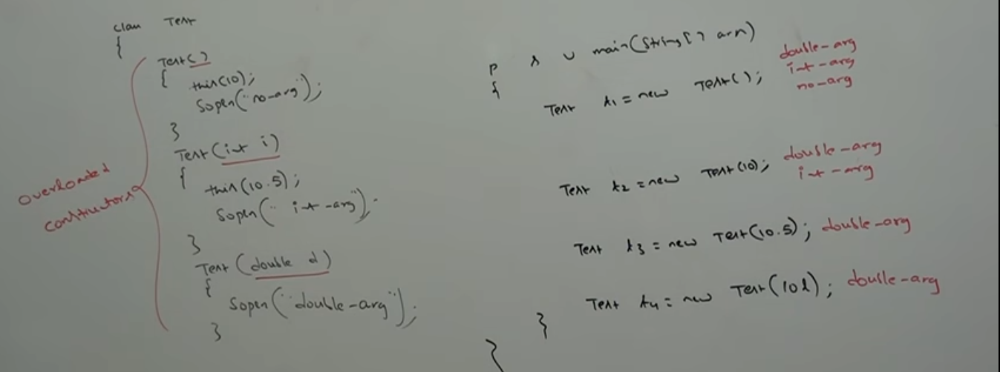

For constructors, inheritance and overriding concepts are not applicable. But overloading concept is applicable.

Every class in java including abstract class can contain constructors. But interface can’t contain constructor.

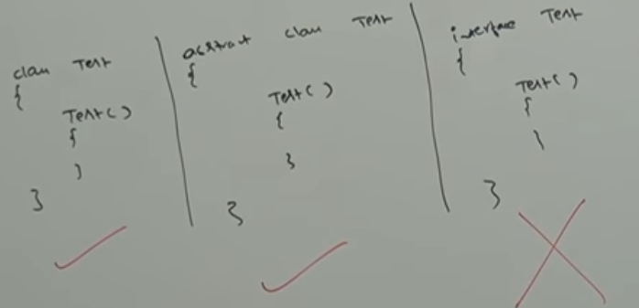

**Case1:** Recursive method is a runtime exception saying Stack Overflow error. If there is a chance of recursive constructor invocation than the code won’t compile and we will get compile time error.

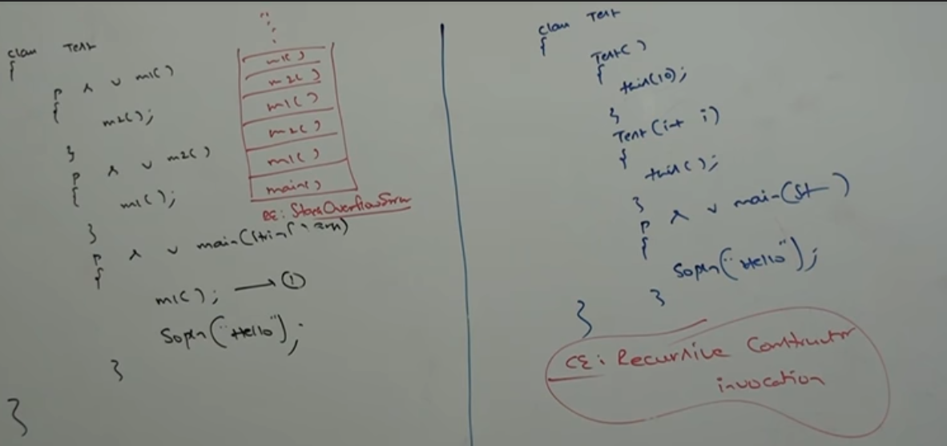

**Case2**: If parent class contains any argument constructors then while writing child classes, we have to take special care with respect to constructors.

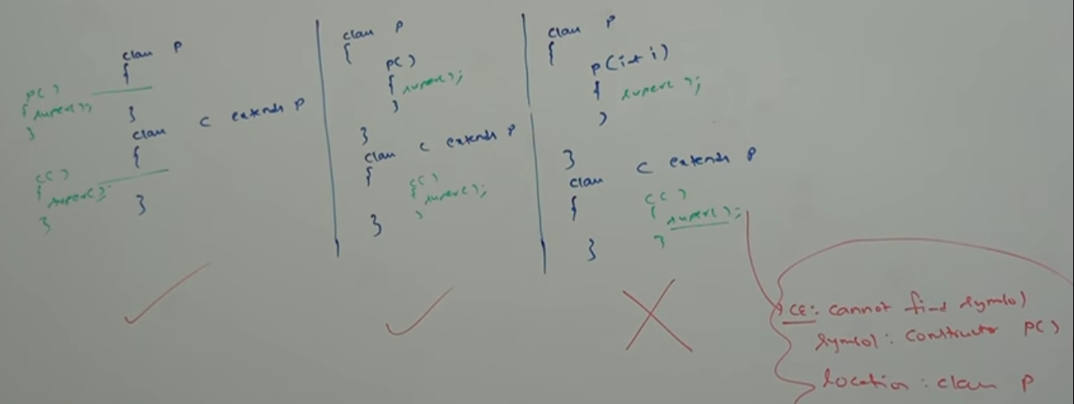

Whenever we are writing any argument constructor it is highly recommended to write no-argument constructors also.

**Case3:**

If parent class constructor throws any checked exception then child class constructor should throw the same checked exception or its parent. Otherwise the code won’t compile.

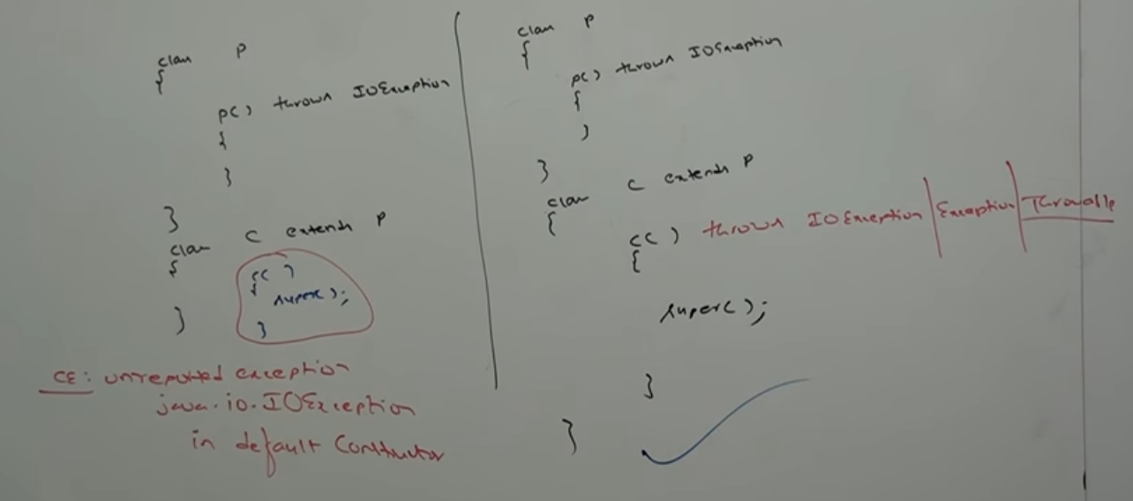

**Singleton class:**

For any java class if we can create only one object such type of class is called Singleton class.

Ex: Runtime, BusinessDelegate, ServiceLocator etc.

**Advantage of Singleton class:**

If several people have same requirement then it is not advisable to create separate object for each requirement.

We must create only one object and can reuse same object for every similar requirement. So, performance and memory utilization can be improved. This is the central idea of Singleton classes.

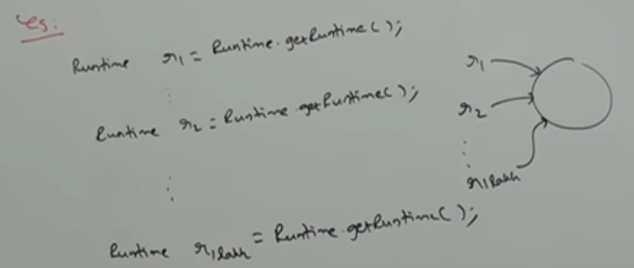

**How to create our own Singleton classes:**

We can create our own singleton classes. For this we must use private constructor and private static variable and public factory method.

**Approach-1:**

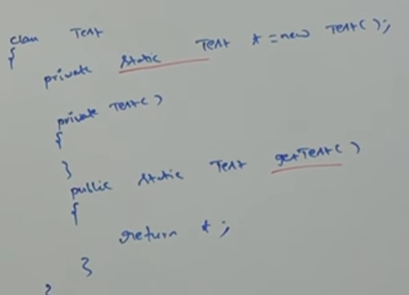

Runtime class is internally implemented by using this approach.

**Approach-2:**

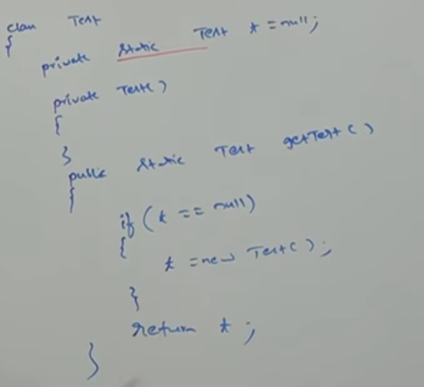

At any point of time for test class we can create only one object. Hence, Test class is Singleton class.

**Approach-3**: **Class is not final but we are not allowed to create child classes.**

By declaring every constructor as private we can restrict child class creation.

Ex: class P {

private p () {}

}

For class P, it is impossible to create child class.